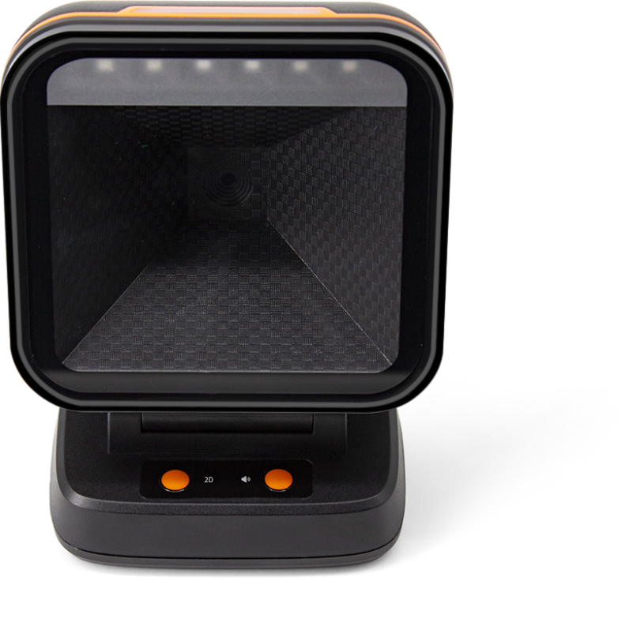

IBC-X1 high-speed 2D scanning platform
Product features
- Equipped with a new 500,000 global exposure CMOS scanning engine
- Larger scanning window, easier to read barcodes
- Adjustable angle, flexible and easy to use
- Common function buttons, easier to setup
- 5 different styles of prompt sound, soft and bright LED indicators
- Multiple interfaces, strong compatibility, support a variety of systems and cash registers

IBC-X1 technical specifications
Physical parameters
Scan mode | Auto-sensing/continuous scanning
Communication interface | USB-HID keyboard, USB-COM virtual serial port, RS232 serial port
Interface type | USB TYPE-B
Prompt mode | Buzzers, LED lights
Set up way | Press the button to set, manually scan the setting code in turn
Shell material | ABS+PC
Cable standards | Straight line 1m
Exterior dimensions | 122mm×160mm×76mm
Weight | 312g (without cable).
Performance parameters
Scan type | CMOS global exposure
Differentiation | 800*600
Light source | 617nm red LED
Scan angle | ± 60°, ±54°, 360° (left and right, front and back, rotation).
Scan rate | 20 cm/s
Field of view angle | 48° (H) x 30° (V)
Print contrast | Minimum 20%.
Decoding Types | 1D: EAN13, EAN 8, UPC-A, UPC-E0, UPC-E1, Code128, Code39, Code93, Interleaved 2 of 5, Industrial 25, Matrix 2 of 5, Code11, CodeBar, MSI, RSS-14, RSS- Ltd, RSS- Exp, Standard 2 of 5, Plessey, ChinaPost 25, GS1 Composite  2D: QR Code, Data Matrix (DM), PDF417, Han Xin, Micro PDF417, Micro QRCode, MaxiCode, Aztec Code, Code16K, support mobile phone screen reading
Minimum resolution | 4 mil
Electrical parameters
Input voltage | DC 5V±10%
Current | Working: 240 mAh; Standby: 190 mAh
Environment parameters
Temperature | 0°C-50°C (working); -20°C~+70°C (storage).
Humidity | 5%-95% non-condensing

The above information is subject to change without prior notice

